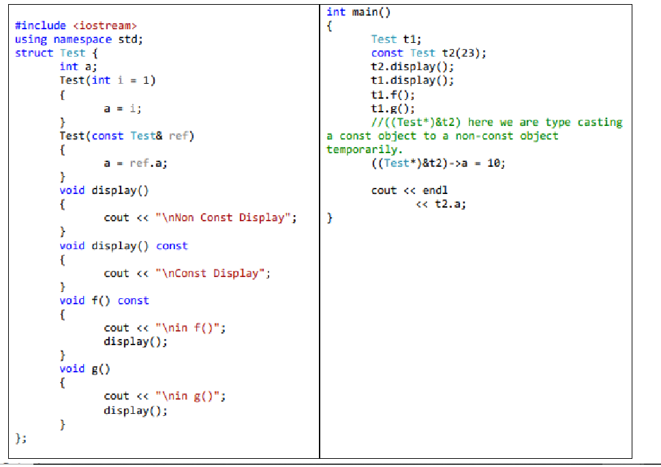
Find attached code run:
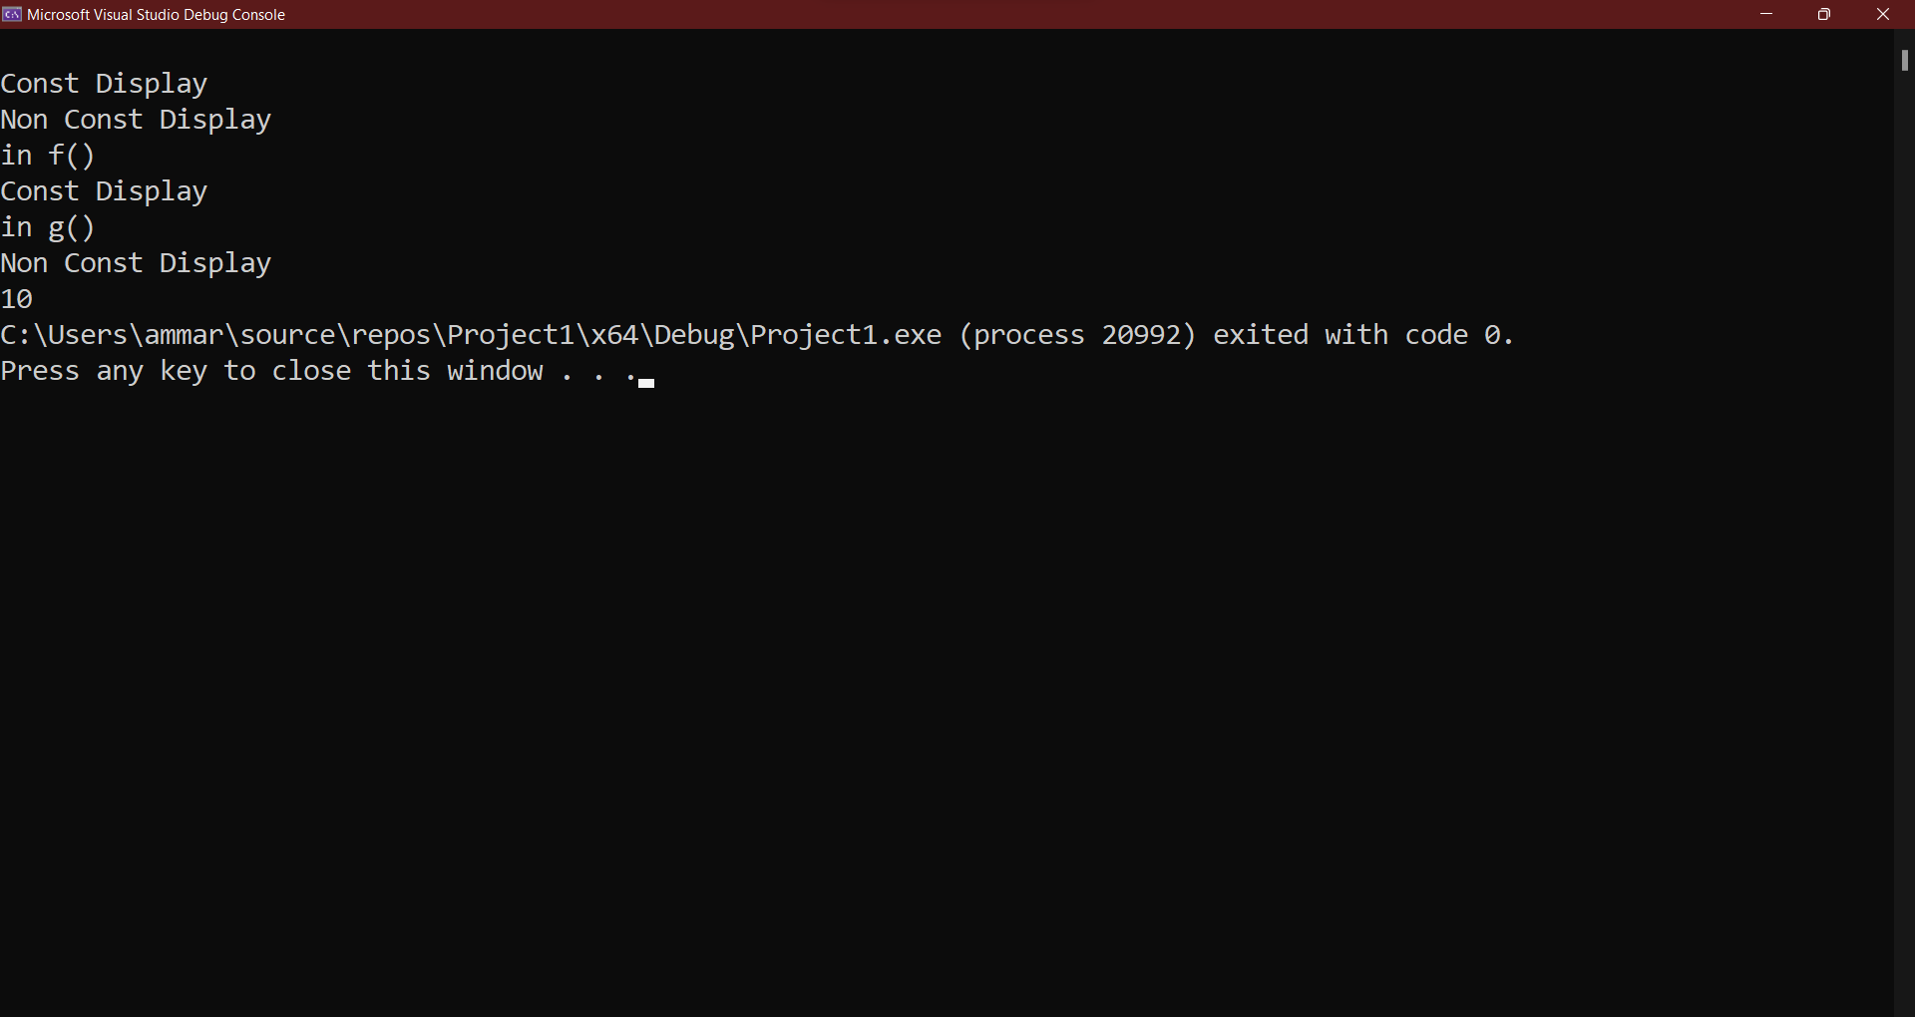

Q2: can const object call const function(s)?
Yes
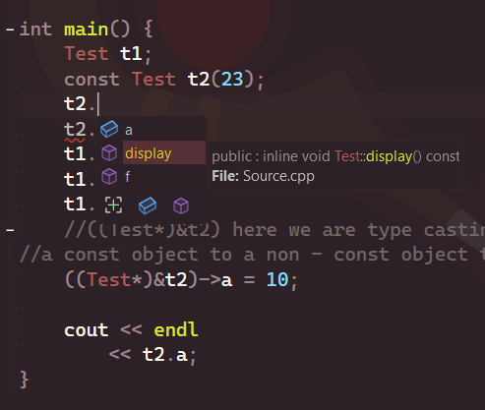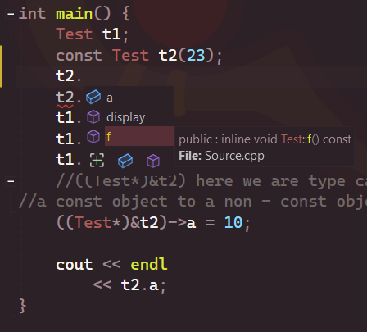

Q3: can const object call non-const function(s)?
No
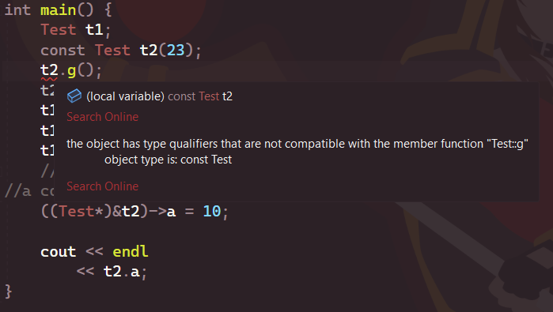

Q4: can non-const object call const function(s)? Yes
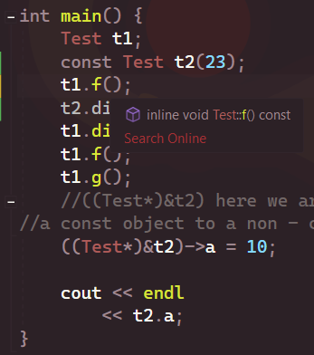
Q5: can non-const object call non const function(s)?
Yes
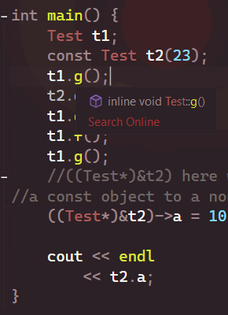
Q6: can const function call const function(s)?
Yes
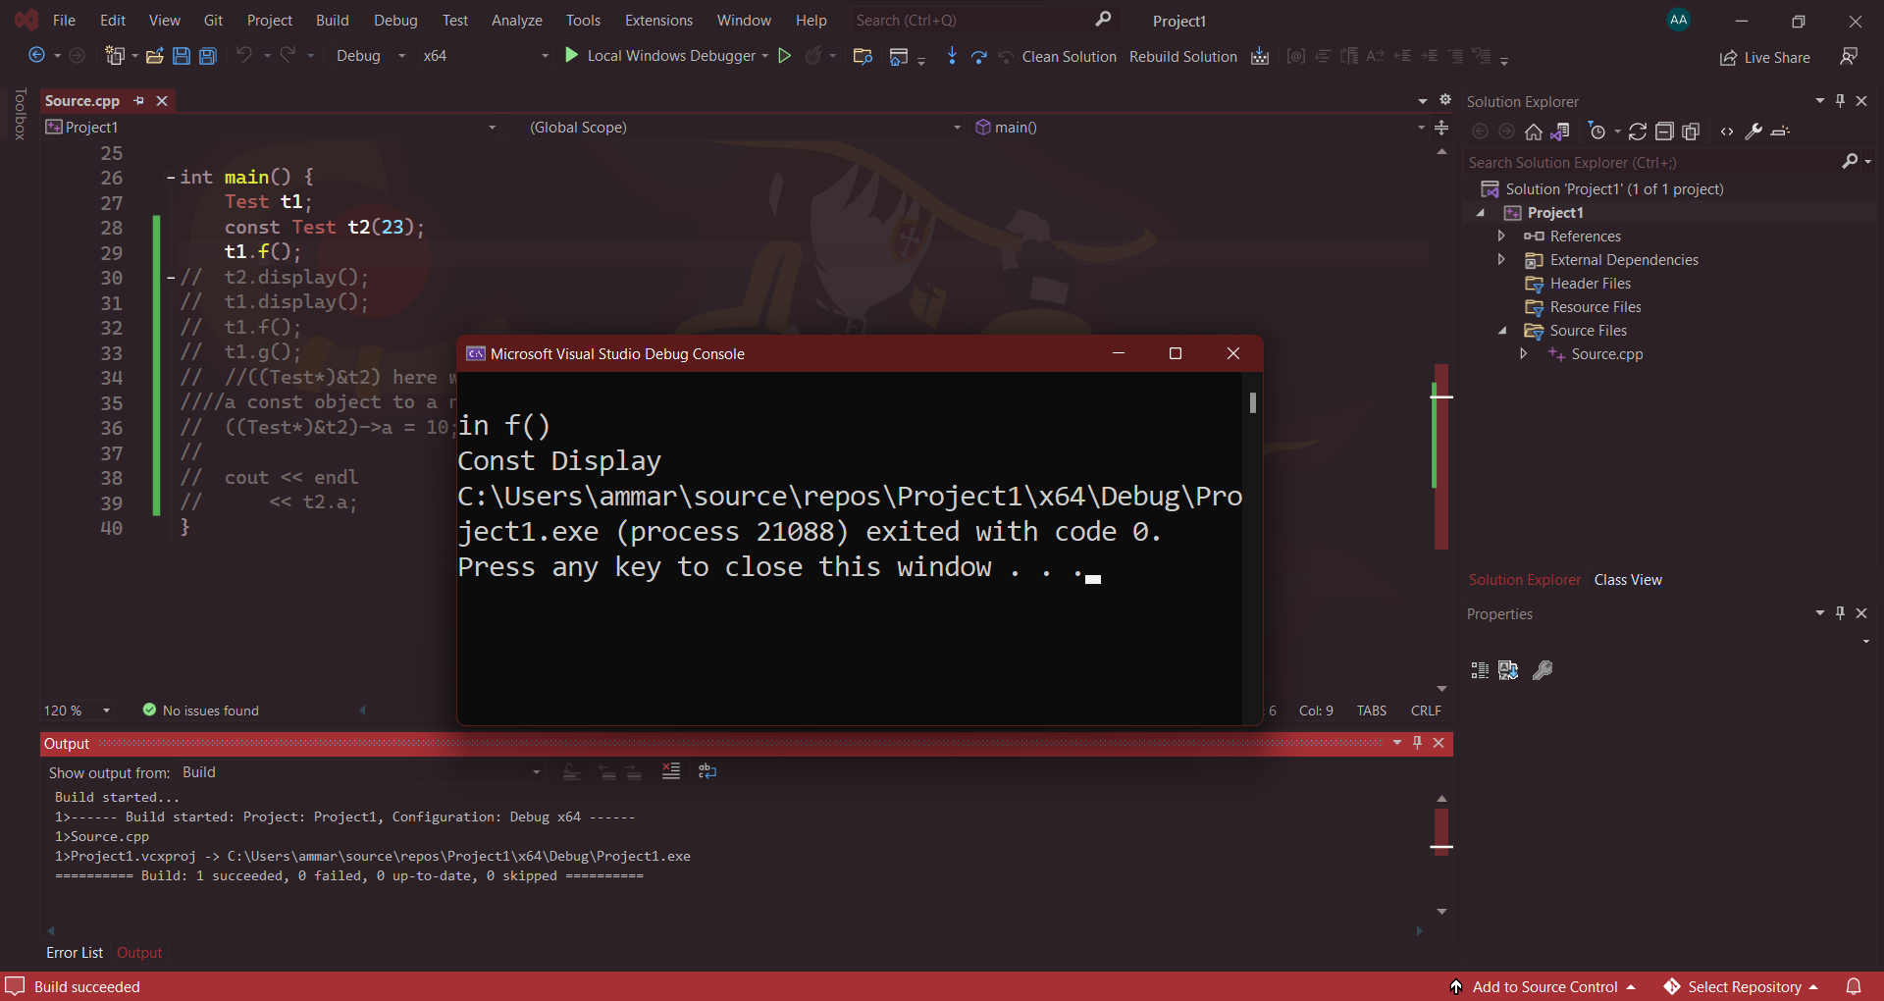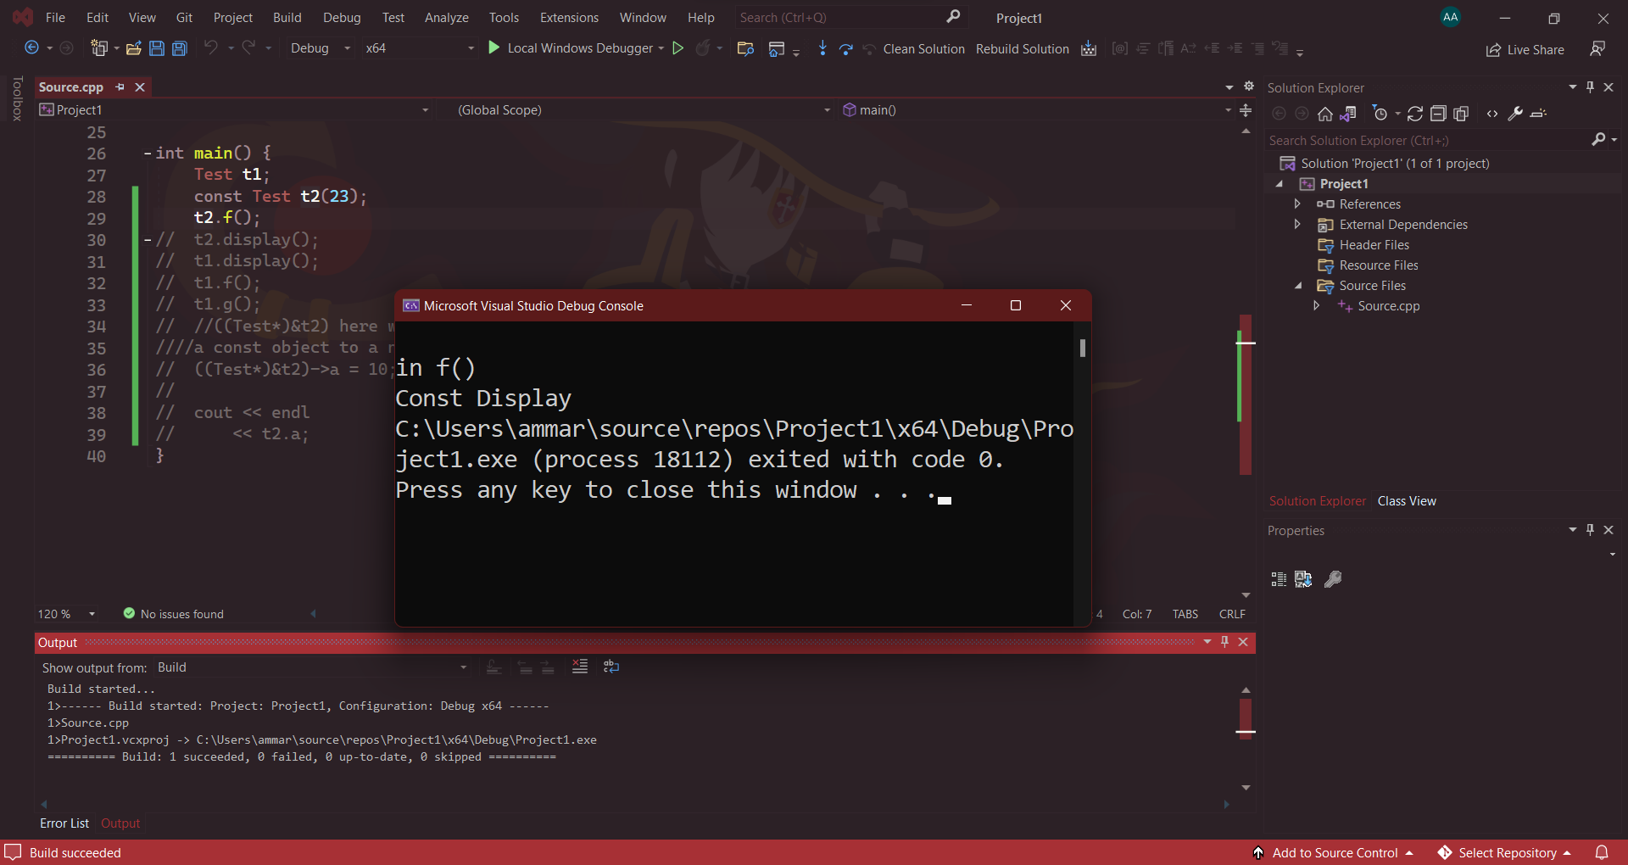

Q7: can const function call non const function(s)?
No, proof is in previous screenshot.

Q8: can non-const function call const function(s)?
No
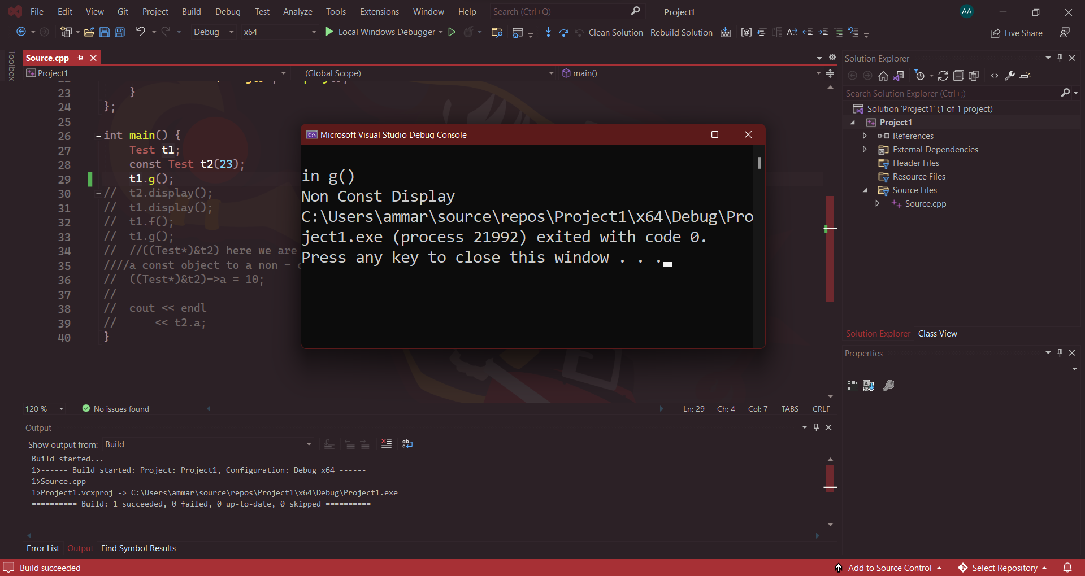

Q9: can non-const function call non const function(s)?
Yes, proof is in previous screenshot.

